**Protocol**

1. Prepare the agar plates.

2. Subject all the agar plate in UVC radiation.

3. Follow the following treatments and controls:

Negative control: Empty agar plate

Positive: Agar plate with S. aureus exposed to UVC (260-265 nm)

Treatment 1: Agar plate with S. aureus exposed to 10 seconds UVC

Treatment 2: Agar plate with S. aureus exposed to 20 seconds UVC

Treatment 3: Agar plate with S. aureus exposed in 30 seconds.

Plating Technique to Be Used: **SPREAD PLATE**

**Requirements**

1. Glasswares
2. Screw-capped test tubes
3. Sterile pipettes
4. Sterile bent glass rods (bent in the shape of a hockey stick), or commercially available sterile spreaders
5. Medium: Plate count agar or nutrient agar. The surface of the plate must not be too moist because the added liquid must soak in so the cells remain stationary.
6. Alcohol (ethanol)

**Procedure for Spread Plate Technique**

**A: Serial dilution**

1. Prepare a series of at least 6 test tubes containing 9 ml of sterile distilled water.
2. Using a sterile pipette, add 1ml of sample to the first tube of the set. Label it as 10^-1.
3. Mix the contents well by swirling the tube upside down a few times.
4. From the first tube, take 1ml of the sample and transfer it to the second tube. Label it as 10^-2.
5. Repeat the procedure with all the remaining tubes labeling them until 10^-6.

**B. Plating**

1. Pipette out 0.1 ml* from the appropriate desired dilution series onto the center of the surface of an agar plate. The surface of the agar must not be too moist because the added liquid must soak in so the cells remain stationary.
2. Dip the L-shaped glass spreader (hockey stick) into ethanol. Ethanol is used to sterilize the glass spreader.
3. Flame the glass spreader over a bunsen burner.
4. Spread the sample evenly over the surface of agar using a cool alcohol-flamed glass rod spreader, carefully rotating the Petri dish underneath at an angle of 45o at the same time.
5. Incubate the plate at 37°C for 24-48 hours.

**\*Note: The volume of the liquid should be 0.1 ml or less. Volumes >0.1 ml are avoided because the excess liquid does not soak in and may cause the colonies to coalesce as they form, making them difficult to count.**

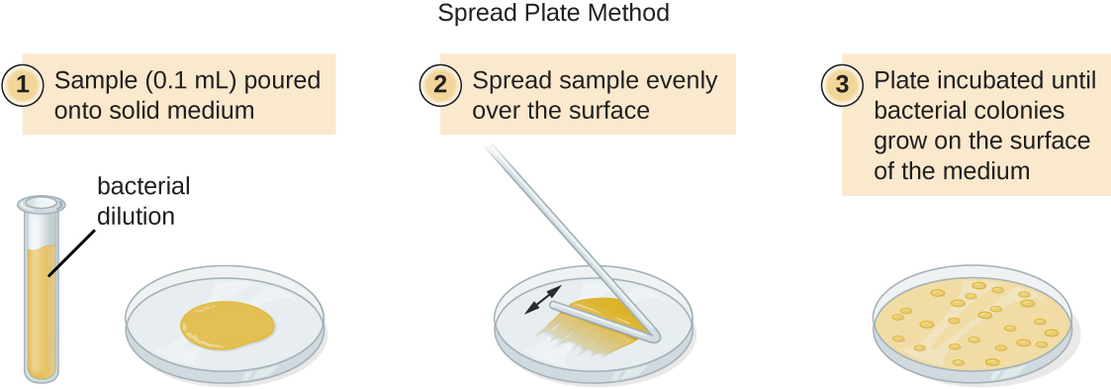

**Calculation of Result**

If your spread plate is successful, after incubation you will get isolated countable colonies evenly spread across the surface of the agar. Count the number of colonies and multiply it by the appropriate dilution factor to determine the colony-forming units (CFU) present per ml in the original sample.

CFU/ml = (number of colonies x dilution factor) / volume of culture plated

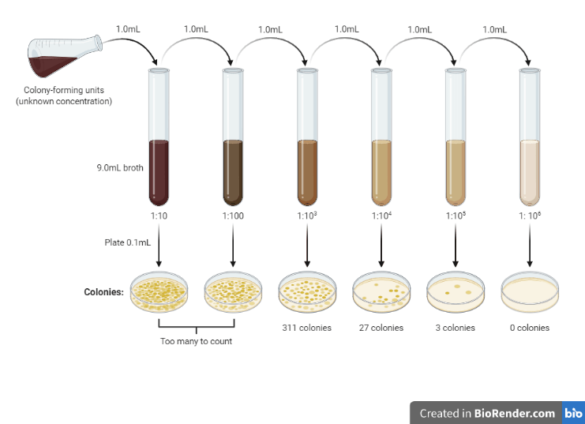

Serial dilution and number of colonies formed (Image source Biorender.com)

For example, suppose the plate of the 10-4 dilution yielded a count of 27 colonies. Then, the number of bacteria in 1 ml of the original sample can be calculated as follows:

Bacteria/ml = (27) x (104 ) x 10 = 2.7 × 106

(we have multiplied by 10 because we have used 0.1mL while plating the agar plate)

References:

Rijal N. (June 2022), “Spread Plate Technique: Principle, Procedure, Results”, “microbeonline.com/spread-plate-technique/”

Sanders ER. Aseptic laboratory techniques: plating methods. J Vis Exp. 2012;(63):e3064. Published 2012 May 11. doi:10.3791/3064